**Deploying of Java Application in APP services using Azure DevOps**

Now we are going to deploy the Java Application in App services using Azure DevOps in practically.

The step by step process is defined below.

Step1: Create a new Organization (my-first-Organization1) within it create a new project (Project-02).

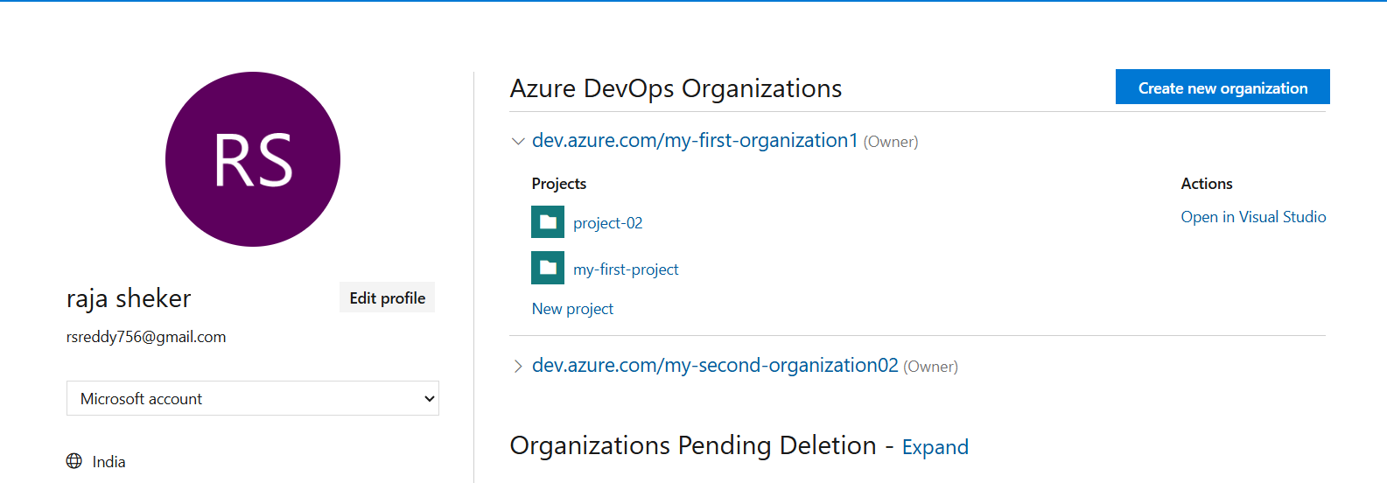

**Fig:** Organization (my-first-organization1).

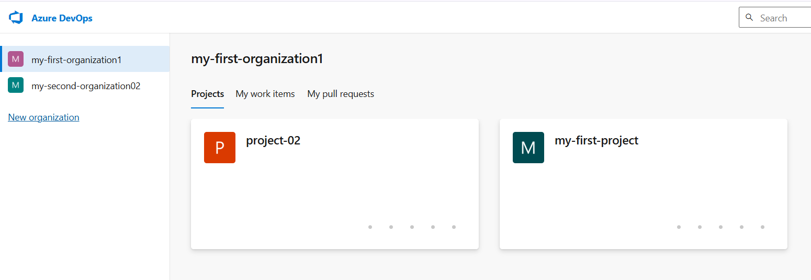

Fig: Project (project-02).